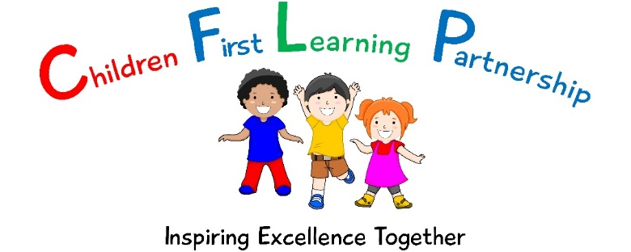

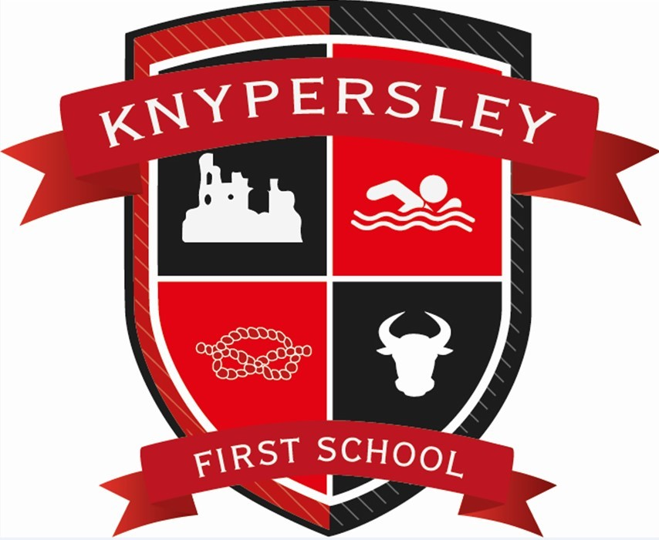
Single Equality Policy and Report
June 2023

3
June 2024
To be reviewed:
June 2023
Agreed and ratified by the Local
Advisory Board on:
Headteacher – Mrs Z. Cooper
Responsible Officer:
Mr J. Flowers
Chair of Local Advisory Board:
The Single Equality Policy has been discussed and adopted by the Local Advisory Board

KNYPERSLEY FIRST SCHOOL 2023-24

Single Equalities Policy

Statement of Principles

The policy outlines the commitment of the staff, pupils and Local Advisory Members of Knypersley First School to ensure that equality of opportunity is available to all members of the school community. For our school this means not simply treating everybody the same but understanding and tackling the different barriers which could lead to unequal outcomes for different groups of pupils in school, whilst celebrating and valuing the achievements and strengths of all members of the school community. These include:

• Pupils
• Staff
• Parents/carers
• The Local Advisory Board
• Multi-agency staff linked to the school
• Visitors to school
• Students on placement

We believe that equality at our school should permeate all aspects of school life and is the responsibility of every member of the school and wider community. Every member of the school community should feel safe, secure, valued and of equal worth and feel able to promote our mission statement of Learn together, Play together, Succeed together.

At Knypersley First School, equality is a key principle for treating all people fairly and creating a society in which everyone has the opportunity to fulfil their potential - irrespective of their gender, ethnicity, disability, religion or belief, (or lack of belief) sexual orientation, age, maternity/pregnancy , civil marriage or any other of the nine recognised area of discrimination, according to the Equality Act of 2010.

Every individual within our school is special and matters to us all.

We aim to:

Promote and develop a learning environment where children are relaxed, happy, secure and eager to learn and where each individual is respected and valued.

Give every individual the opportunity to develop to their full potential within a positive whole school culture that is determined and committed to raising standards.

Develop basic learning skills for life through a broad balanced and highly engaging creative curriculum which promotes a healthy and active lifestyle.

Encourage children to become well-motivated, independent and self-disciplined individuals who are willing to make a positive contribution to all aspects of school life.

Seek opportunities to work in partnership with our parents, carers and appropriate members of our community to help us achieve our goals.

Our pupils believe that it is important that we welcome everyone to our school and we must try hard to make sure that both the adults and pupils are all fully included in the life of the school. Knypersley First School is a happy family and everyone in it is special in their own way.
School in Context

- There are currently 172 boys and 171 girls on roll in our school.
- 99% of our pupils speak English as a first language
- 99% of our pupils are White British
- 1 pupil is EAL (0.29%)
- 100% of staff and Local Advisory Board members are White British
- Currently we have 4 looked after children in our school.
- Our school is extremely accessible with wheel chair ramps and lifts available.

Ethos and Atmosphere
- At Knypersley First school, the leadership of the school community will demonstrate mutual respect between all members of the school community
- There is an openness of atmosphere which welcomes everyone to the school
- All within the school community will challenge any type of discriminatory and/or bullying behaviour, eg through unwanted attentions (verbal or physical) and unwelcome or offensive remarks or suggestions
- All pupils are encouraged to greet visitors to the school with friendliness and respect
- The displays around the school are of a high quality and reflect diversity across all aspects of equality of opportunity and are frequently monitored
- Provision is made to cater for the spiritual needs of all the children through planning of assemblies, classroom based and externally based activities

Policy Development
This policy applies to the whole school community. It has been drawn up as a result of the outcomes of a transparent process and through consultation with:
Parents, pupils, Local Advisory Board and staff.
Monitoring and Review

Knypersley First School is an inclusive school, working towards greater equality in the whole school community. We use the curriculum and teaching to enhance the self-esteem of all those it serves and to provide a learning environment in which each individual is encouraged to fulfil her or his potential.
We collect and analyse a range of equality information for our pupils/students:

Attainment data, attendance data, exclusions, involvement with extended learning opportunities, complaints of bullying or harassment and behaviour records are analysed by ethnicity, disability, gender, pupil premium, LAC, able and talented groupings and SEN.

We make regular assessments of pupils’ learning and use this information to track pupils’ progress, as they move through the school. As part of this process, we regularly monitor the performance of the different groups listed above, to ensure that all groups of pupils are making the best possible progress. We use this information to adjust future teaching, adult deployment to support a variety of learning styles as necessary.
Resources are available to support groups of pupils where the information suggests that progress is not as good as it should be. The governing body receives regular updates on pupil performance information.

School performance information is compared to national data and local authority data, to ensure that pupils are making appropriate progress when compared to all schools, and to schools in similar circumstances.

As well as monitoring pupil performance information, we also regularly monitor a range of other information. This relates to:
- Attendance
- Exclusions and truancy
- Sex, race, religion and belief, disability, sexual orientation or gender reassignment
- Parental involvement
- Participation in Extended Learning Opportunities

Our monitoring activities enable us to identify any differences in pupil performance and provide specific support as required, including pastoral support. This allows us to take appropriate action to meet the needs of specific groups in order to make necessary improvements.

Knypersley First School is also committed to providing a working environment free from discrimination, bullying, harassment and victimisation. We aim to recruit an appropriately qualified workforce and establish a Local Advisory Board that is representative of all sections of the community in order to respect and respond to the diverse needs of our population. Due regard is given to the legislation regarding pregnancy and maternity with reference to our school staffing policies.
We collect and analyse a range of profile information for our staff and Local Advisory Board:
For example, applicants for employment, staff profile, Local Advisory Board profile, attendance at training events, disciplinary and grievance cases and staff appraisal/performance management.
We have identified the following issues from the analysis of the data:
The staff and Local Advisory Board profile demonstrates a gender imbalance, with only 2 male teachers (19%) and 1 male support staff out of 44 (2%) and only 2 male Board Members.
Due regard is given to the promotion of equality in the School Development Plan and monitored through the equality targets and report.

Developing Best Practice

Learning and Teaching

We aim to provide all our pupils with the opportunity to succeed, and to reach the highest level of personal achievement. To do this, teaching and learning will:

- Provide equality of access for all pupils and prepare them for life in a diverse society
- Use materials that reflect a range of cultural backgrounds, without stereotyping
- Use materials to promote a positive image of and attitude towards disability and people with disabilities.
- Use materials which promote a positive image of and attitude towards same sex partnerships and family groups.
- Promote attitudes and values that will challenge discriminatory behaviour
- Provide opportunities for pupils to appreciate their own culture and religions and celebrate the diversity of other cultures
- Use a range of sensitive teaching strategies when teaching about different cultural and religious traditions
- Develop pupil’s advocacy skills so that they can detect bias, challenge discrimination, leading to justice and equality
- Ensure that the whole curriculum covers issues of equality and diversity;
- All subject leaders, where appropriate, promote and celebrate the contribution of different cultures to their subject area
- Seek to involve all parents in supporting their child’s education
- Provide educational visits and extended learning opportunities that involve all pupil groups
- Take account of the performance of all pupils when planning for future learning and setting challenging targets
- Make best use of all available resources to support the learning of all groups of pupils
- Identify resources and training that support staff development

Learning Environment

There is a consistently high expectation of all pupils regardless of their gender, ethnicity, disability, religion or belief, sexual orientation, age or any other recognised area of discrimination. All pupils are encouraged to improve on their own achievements and not to measure themselves against others. Parents are also encouraged to view their own children’s achievements in this light.

- Teacher enthusiasm is a vital factor in achieving a high level of motivation and good results from all pupils
- Adults in the school will provide good, positive role models in their approach to all issues relating to equality of opportunity
- The school should place a very high priority on the provision for special educational needs and disability.
- We will meet all pupils’ learning needs including the more able by carefully assessed and administered programmes of work
- The school must provide an environment in which all pupils have equal access to all facilities and resources
- All pupils are encouraged to be actively involved in their own learning
- A range of teaching methods are to be used throughout the school to ensure that effective learning takes place at all stages for all pupils
- Consideration will be given to the physical learning environment – both internal and external, including displays and signage

Curriculum

At Knypersley First School, we aim to ensure that:

- Planning reflects our commitment to equality in all subject areas and cross curricular themes promoting positive attitudes and an understanding of equality and diversity
- Pupils will have opportunities to explore social and emotional issues relating to identity and equality
- Staff are mindful to ensure that all pupils have access to the to full breadth of our curriculum by taking into account their cultural, backgrounds, linguistic needs and learning styles
- All pupils have access to a well planned curriculum which recognises attainment and achievement and promotes high rates of progression for all.

Resources and Materials

The provision of high quality resources and materials within Knypersley First school is of the upmost priority. Any resources purchased should:

- Reflect the reality of an ethnically, culturally and sexually diverse society
- Reflect a variety of viewpoints
- Show positive images of males and females in society
- Include non-stereotypical images of all groups in a global context
- Be accessible to all members of the school community

Language

We recognise that it is important at Knypersley First school that all members of the school community use appropriate language which:

- Does not transmit or confirm stereotypes
- Does not offend
- Creates and enhances positive images of particular groups identified at the beginning of this document
- Creates the conditions for all people to develop their self esteem
- Uses accurate language in referring to particular groups or individuals and challenges in instances where this is not the case

Extended Learning Opportunities

It is the policy of this school to provide equal access to all activities from an early age.

We undertake responsibility for making contributions to extended learning opportunities and are aware of the school’s commitment to equality of opportunity (e.g. parent helpers and students by providing them with written guidelines drawn from this policy.)

We try to ensure that all such non staff members who have contact with children adhere to these guidelines.

Provision for Bi-lingual Pupils

We undertake at Knypersley First School to make appropriate provision for all EAL/bi-lingual children/groups to ensure access to the whole curriculum. These groups may include:

- Pupils for whom English is an additional language
- Pupils who are new to the United Kingdom
- Gypsy, Roma and Traveller Children
- Advanced bi-lingual learners
- Use first language effectively for learning

Personal Development and Pastoral Guidance

- Staff take account of gender, ethnicity, disability, religion or belief, sexual orientation, age or any other recognised area of discrimination and the experience and needs of particular groups such as Gypsy, Roma and Traveller, refugee and asylum seeker pupils
- All pupils are encouraged to consider the full range of career opportunities available to them with no discriminatory boundaries placed on them due to their disability, gender, race or sexual orientation (whilst acknowledging that a disability may impose some practical boundaries to some career aspirations)
- All pupils/staff/parents/carers are given support, as appropriate, when they experience discrimination
- We recognise that perpetrators may also be victims and require support.
- Positive role models are used throughout the school to ensure that different groups of pupils can see themselves reflected in the school community
- Emphasis is placed on the value that diversity brings to the school community rather than the challenges.

Staffing and Staff Development

We recognise the need for positive role models and distribution of responsibility among staff.

- This must include pupils' access to a balance of male and female staff at all key stages where possible
- We encourage the career development and aspirations of all school staff
- It is our policy to provide staff with training and development, which will increase awareness of the needs of different groups of pupils
- Access to opportunities for professional development is monitored on equality grounds

Staff Recruitment

- All those involved in recruitment and selection are trained and aware of what they should do to avoid discrimination and ensure equality good practice through the recruitment and selection process
- Equalities policies and practices are covered in all staff inductions
- All temporary staff are made aware of policies and practices
- Employment policy and procedures are reviewed regularly to check conformity with legislation and impact

Partnerships with Parents/Carers/Families and the Wider Community

We will work with parents/carers to help all pupils to achieve their potential.

- All parents/carers are encouraged to participate in the full life of the school.
- Setting up, as part of the schools’ commitment to equality and diversity, a group made up of all stakeholders of the school community. This has been/will be developed to support the school with matters related to its equalities duties
- Members of the local community are encouraged to join in school activities
- Exploring the possibility of the school having a role to play in supporting new and settled communities

Roles and Responsibilities

- Our Local Advisory Board will ensure that the school complies with statutory requirements in respect of this policy and action plan
- The Headteacher is responsible for the implementation of this policy, and will ensure that staff are aware of their responsibilities, that they are given necessary training and support and report progress to the Local Advisory Board
- The Headteacher has day-to-day responsibility for co-ordinating the implementation of this policy
- Our staff will promote an inclusive and collaborative ethos in the school, challenge inappropriate language and behaviour, respond appropriately to incidents of discrimination and harassment, ensure appropriate support for children with additional needs and maintain a good level of awareness of equalities issues
- Be aware of the Equality Policy and how it relates to them
- Make known any queries or training requirements
- Behaving with respect and fairness to all members of the school community
- All members of the school community have a responsibility to treat each other with respect, to feel valued, and to speak out if they witness or are subject to any inappropriate language or behaviour
- We will take steps to ensure all visitors to the school adhere to our commitment to equality

Commissioning and Procurement

Knypersley First School will ensure that we buy services from organisations that comply with equality legislation. This will be a significant factor in any tendering process.

The Measurement of Impact of the Policy

This policy will be evaluated and monitored for its impact on pupils, staff, parents and carers from the different groups that make up our school each year. An action plan is reviewed annually and published to show progress and impact towards the targets.

