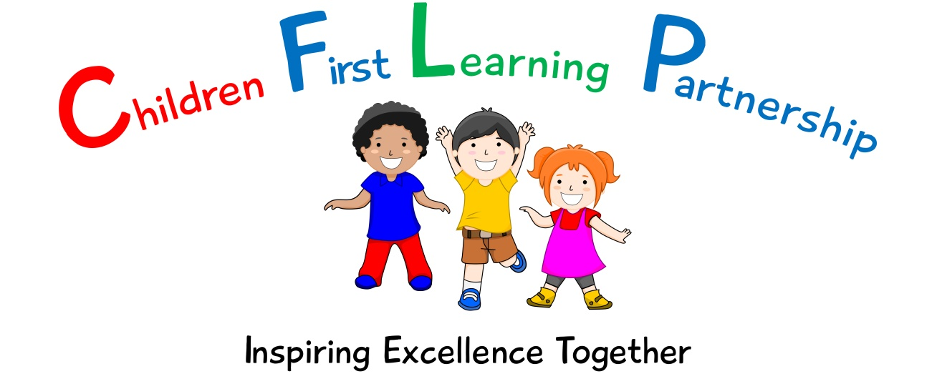
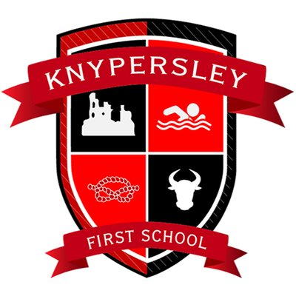

Art Policy 2023

February 2024
To be reviewed:
________________
Agreed and ratified by the Local Advisory Board on:
Headteacher- Mrs Z.Cooper
Responsible Officer:
Mr J.Flowers
Chair of Local Advisory Board:
The CFLP Art Policy in respect of the Children First Learning Partnership has been discussed and adopted by the Local Advisory Board.

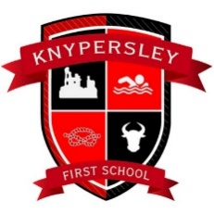

Knypersley First School
Art Policy 2023

The overall intent of our school curriculum is to:
Recognise uniqueness: in our pupils, staff, resources and whole school community.
Be Inclusive: recognising learning styles, learning needs at all levels and providing solutions to any barriers to learning we encounter.
Engage and Inspire: through knowledge rich, highly enriched, progressive and purposeful contexts.
Promote Aspiration: offering challenge, accountability and responsibility for their learning.
Create citizens of the Future: who thrive on responsibility, see difference as a strength of our community and use democracy to embed their own values and beliefs.
Our Art curriculum strives to drive all of these intentions and links very closely to the achievement and development of them all.
Intent
To develop children’s experience of Art by imaging, creating and exploring through different mediums.
We aim to achieve this through allowing the children:
- To develop a broad knowledge and understanding of a range of famous artists, craft makers and designers.
- To develop knowledge and understanding of shape, pattern, colour, texture and form to express emotions and individuality.
- To show a passion and enjoyment for artwork.
- To draw confidently and adventurously from observation, memory and imagination.
- To select and use materials and techniques skilfully and inventively that are fit for purpose.
- To develop independence, initiative and originality which they use to develop their own and others’ creativity.
- To be able to reflect, talk about and improve their own work and that of others.
Implementation
We use the Development Matters and National Curriculum documents to inform the delivery of Art and Design at Knypersley First School.

Our progression documents show a build-up of knowledge and skills across the following areas:
KS1 – where they use a range of materials to design and make products; use drawing, painting and sculpture to develop and share ideas, experience and imagination; to develop a wide range of Art and Design techniques in using colour, pattern, texture, line, shape, form and space; learn about the work of a range of artists, craft makers and designers, describing the differences and similarities between different practices and disciplines, and making links to their own work; begin to use sketchbooks to explore new ideas and revisit skills.
KS2 – where they learn about and take inspiration from notable artist/architects/designers, to master a wide range of Art and Design techniques in using colour, pattern, texture, line, shape, form and space; and create sketchbooks to record their observations and use them to review and review and revisit ideas.

Art and Design Techniques
In order to ensure the depth and breadth of our Art curriculum it has been designed in a way in which it complements the units of study in Design and Technology so that skills are revisited and built upon in alternate years. As drawing and painting underpin many areas of Art, they are studied in every year group across the school.
In Year 1, 3 and 5 children will learn how to draw, paint, investigate and explore textiles and print.
In Year 2, 4 and 6 children will learn how to draw, paint, sculpt and create collage.

Artists
A focus artist (see artist overview – appendix 1) will be covered as part of each Art and Design unit that is taught. This is to ensure that children gain a depth and breadth of knowledge regarding artists, craft makers, designers and architects. We ensure that children study artists from a range of ethnicities, cultures and backgrounds in order to expose children to the wider world and support their cultural capital.

The children’s artwork can be a replication of the studied artists content or technique, or inspired by elements of the artist’s work.

Sketchbooks
Children will be provided with a sketchbook from the start of Year 1. This will then follow them through the school to the end of Year 6. When one sketchbook is filled a new one will be provided.

Sketchbooks will demonstrate children’s exploration and experimentation of different skills and techniques. Children are encouraged to make annotations as they work so that the sketchbook can be used to inform a final piece.

Learning objectives are stuck in via a label to ensure that children know the intended outcome of the lesson and these can be used as a tool when looking back on previous learning.

Sketchbooks are not marked – feedback is given live during the moment.

Celebrating Art
Final pieces of artwork are created in a variety of ways and are not restricted to a sketchbook. This allows for children’s artwork to be celebrated and presented in different ways, such as; displays, social media and being shared with family members.

Unit/Lesson Structure
A Unit of Work (Pathway)
A unit of work typically incorporates the following:
- National Curriculum Programmes of Study are used, alongside our subject specific progression documents, for long-term and medium-term planning.
- Kapow is used to support staff in short term planning.
- An Artist study is used to explore techniques, meaning and content of artwork, which the children can use to inspire their own artwork.
- Retrieval of knowledge, skills and vocabulary from previous year and lesson are revisited and recalled, allowing links to made with pre-existing schema.
- Vocabulary- a wide range of Art and Design vocabulary is to be modelled and used in context to demonstrate understanding. The vocabulary documents set out clear expectations for each year group.
- Teach and model specific Art and Design techniques, that the children are given time to refine before applying them to their own piece of artwork.
- Ongoing assessments through questioning, observations and outcomes are used to analyse and inform the support, challenge and next steps for the children.
- Application to a composite – children’s knowledge and skills of the unit to be applied in a final piece of work.
- Evaluate – children take part in ongoing self-reflection throughout the unit culminating in a formal, constructive critique of their final artwork.

A Lesson (Pathway)
Lessons are planned from the correct Key Stage Programmes of Study from The National Curriculum and our progression documents. Teachers will be aware of the prior learning that needs to be secure from previous year groups to ensure new content can be understood. Lessons are planned sequentially, to ensure knowledge and skills are built upon.

A lesson would typically consist of the following:
- Retrieve - used to revisit and retrieve previously taught knowledge/skills.
- Shared learning objective, success criteria and unit specific vocabulary - help to set the context for a lesson.
- Teaching exposition - a variety of strategies are used to model and explore new concepts.
- Opportunities to discuss learning - children are encouraged to speak in full sentences and reinforce vocabulary in context.
- Assessment for learning (AfL) questions - used to extend and/or support learning.
- Practise/Apply – a range of opportunities to embed skills/knowledge taught.
- Scaffolded learning activities - linked to the learning objective to ensure all children achieve the learning outcome.
- Reflection – a range of techniques are employed to encourage children to think about and discuss their own learning.
- Evaluate – refer back to learning objective and success criteria. This could be at any point throughout the lesson.
These elements could be used flexibly throughout each session.
Impact
What we aim to achieve from our Art curriculum across the Children First Learning Partnership;
- Children will have a broad knowledge and understanding of a range of famous artists, craft makers and designers.
- Children will have a broad knowledge and understanding of the formal elements of Art.
- Children will be able to produce artwork that expresses emotion and individuality.
- Children will foster a passion and enjoyment for artwork.
- Children will be able to draw with confidence from observation, memory and imagination.
- Children will be able to select and use materials and techniques skilfully and inventively.
- Children will be able to select and use materials that are fit for purpose.
- Children will be independent and willing to take creative risks.
- Children will use their initiative and originality to develop their own and others artwork.
- Children will be able to reflect, talk about and improve their own work and that of others.

Assessment
Assessment within Art is based upon many sources of evidence. This will allow for judgements to be evidenced based and secure regarding what pupils know and remember in relation to our planned curriculum outcomes in all year groups. Teachers will use a variety of assessment methods which they will select carefully based upon the quality of evidence it will provide within Art and will avoid additional workload for pupils and staff.
Formative assessment takes many forms in Art

AfL
Teachers and subject leaders value the voice of the pupil. They will observe pupils carefully, question purposefully and listen and use pupil responses in all lessons and the day to day life of the school to adapt teaching in the moment, lesson to lesson and unit to unit to ensure learning is secure and built upon in a sequential and progressive manner. In many lessons and where appropriate, purposefully planned explicit retrieval opportunities will also be used to ensure pupils have secured component knowledge and are ready to move on and make links to previous learning.

Evidence Me
A wealth of other evidence such as practical hands on learning outcomes, behaviours, drama, performances, and group work will also be captured on evidence me to support teacher assessment judgements. At Knypersley First School, we value talk, practical exploration and pupil responses as a method of ensuring all pupils can access our Art curriculum and demonstrate the gains they are making simply and effectively.
Summative assessment in Art may in some year groups be available to aid the judgements teachers make about what pupils know and remember:

Pupils work, end of unit quizzes and composite outcomes
Pupils, will where appropriate, capture their understanding, evaluate their own learning or rehearse and secure knowledge in a written form. This will be used effectively to evidence progress and avoid creating barriers to learning for any group of pupils in our school, for example due to their age or any additional needs they may have.

Teacher Assessment Judgements
Children will be judged as meeting curriculum expectations in Art on a termly basis using evidence from the activities listed above. This judgement will be working at, below or at a greater depth within the year group/key stage unit they have completed. This will be captured on our Arbor system and used to inform curriculum design and developments, resourcing, training and leadership monitoring activities. Teacher assessment judgements in Art will be shared with parents on an annual basis via their child’s annual report.

Role of Leaders
- Lead the development of Art and Design in the school, including identifying the next steps and driving the subject forward.
- Provide CPD opportunities (training, staff meetings, planning clinics, drop-ins and ongoing support) to develop staff.
- Conduct leader research to ensure the subject knowledge and understanding of the leader is up to date. This is disseminated to staff when appropriate.
- Review, monitor and feedback current practice within the subject.
- To ensure that all resources are available for each unit.
Version | Review Date | Changes Made

Appendix 1- Knypersley First School Artist Overview

 | Autumn | Spring | Summer
Year 1 | Drawing  Bridget Riley (line and mark making)  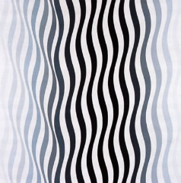  Composite – Collaborative piece of artwork using different lines. E.g. pumpkin | Painting  Clarice Cliff (colour theory, mixing primary colours to make secondary colours)  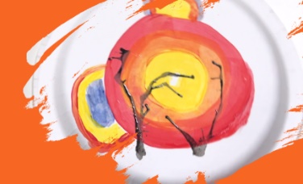  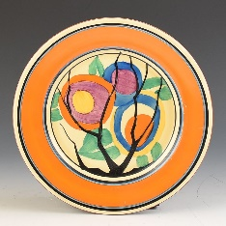  Composite – Create a painting in the style of Clarice Cliff using colours, shapes and techniques recognised in her work.  Textiles  Katrina Sánchez Standfield (weaving)  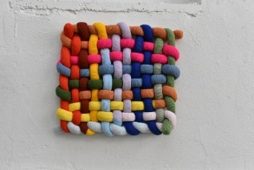  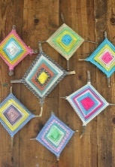  Composite – Create a decorative piece of artwork using weaving. | Printing  Andy Warhol (repetition, printing, inspiration for mono print, use of colour)  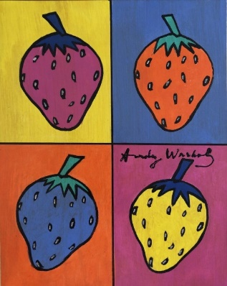  Composite – Create your own fruit based repeating pattern using a loaded print method.  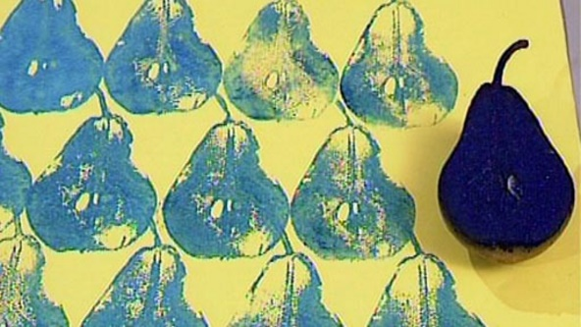
Year 2 | Drawing  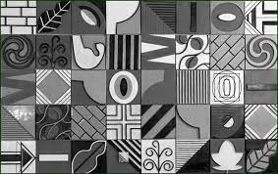  Nancy McCroskey (tone)  Ian Murphy (tone, shade, architecture)  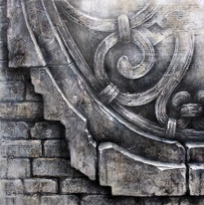  Composite – Chn to sketch and shade key architecture found in and around Knypersley. | Painting  James M W Turner  (Romanticism painting of seascapes/landscapes)  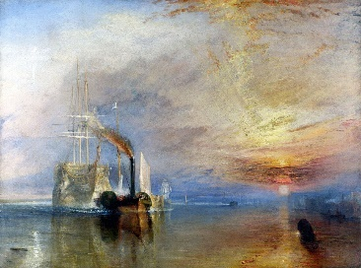  Composite- Chn to create their own seascape using watercolours, inspired by the artist. Use as a background to mount watercolour painting of Titanic.  Collage  Megan Coyle (mixed media collage)  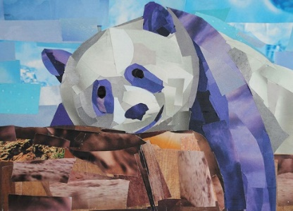  Composite – Create a collage animal using a range of media to represent realistic colours and shapes and begin to overlap the materials.  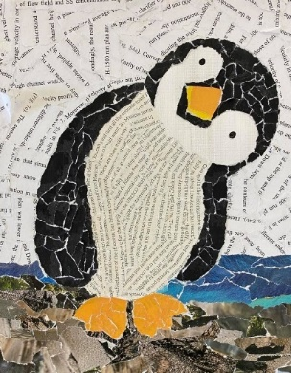 | Sculpture  Philippe Faraut (Scultpure, clay work to create 3D models of faces)  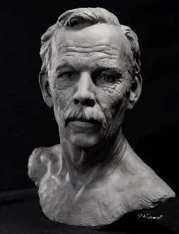  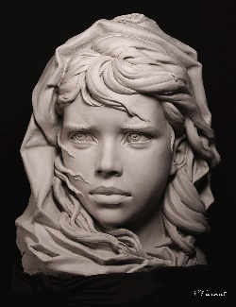  Composite- Chn to create their own sculpture portrait of themselves with 3D elements.
Year 3 | Drawing  Sid Kirkham (tonal and 3D drawing)  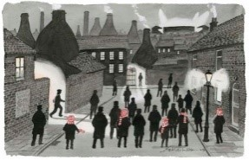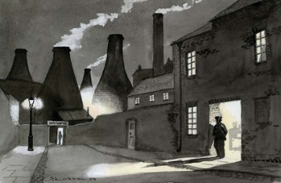  Composite – Chn to create a drawing in the style of Sid Kirkham using shadow and texture to make an object appear 3D. | Painting  Edward Middleton Manigault (secondary colours-tones, applying paint in different ways, using brushes in different ways)  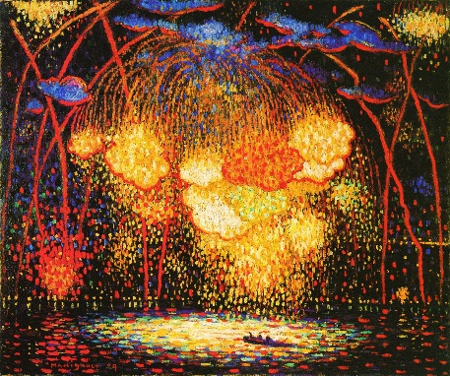  Composite – Use paint in different ways with different tones/brightness of secondary colours to create a fireworks scene on black card.  Textiles  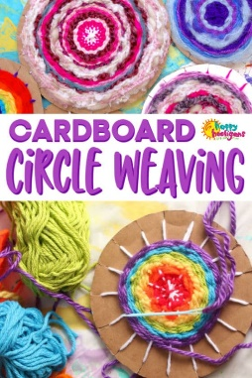  Vivien Prideaux (natural dyes)  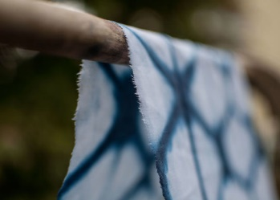  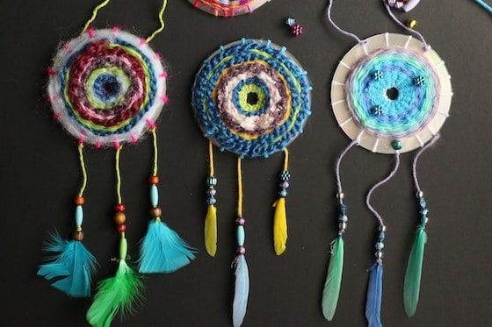  Composite – Use cardboard circle weaving to create and embellish a woven dreamcatcher. Using a range of fabrics/wool etc and those that have been dyed by the children. | Printing  Sarah Jameson  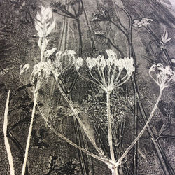  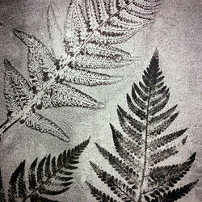  Composite – Monoprint from an ink block by carefully removing unwanted ink to create an natural print inspired by the artist. (Challenge to create a textured/multimedia canvases to print on to.
Year 4 | Drawing  Roy Lichtenstein. (Use of shapes, patterns and colour to create depth within still life.)  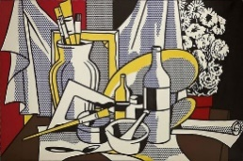  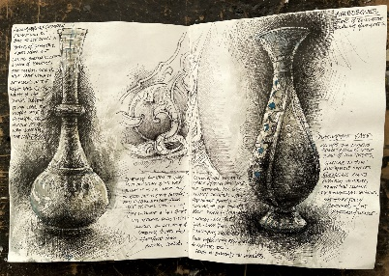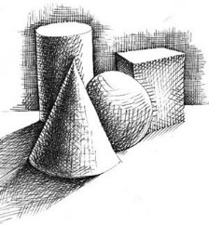  Composite – Draw still life from observation using cross hatching and tonal skills to create 3D work. Applied to a background inspired by the artist. | Painting  Pablo Picasso (cool colours to express mood, cubism movement)  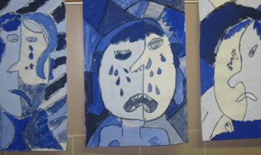  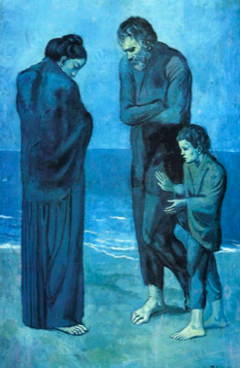  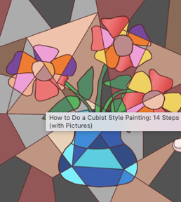  Composite – Create a painting in the style of Pablo Picasso, using the cubism style and choosing a colour pallet to show feelings and mood.  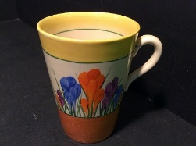  Sculpture  Local potters.  Clarice Cliff  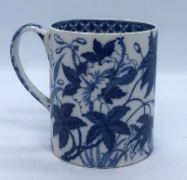  Josiah Wedgewood  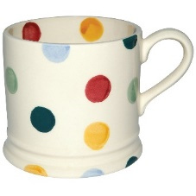  Emma Bridgewater  Composite – Create a functional mug with a handle that is attached and decorate it in the style of one of the given potters. | Collage  Kurt Schwitters (collage)  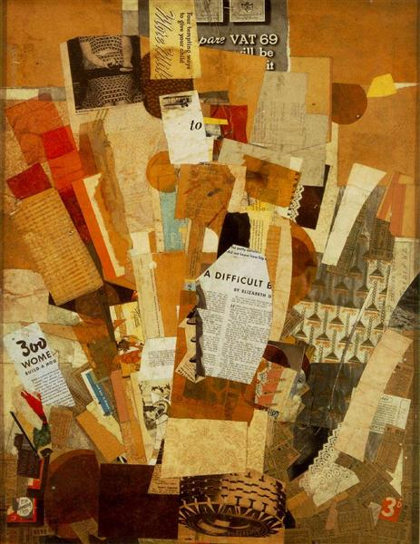  Composition – Create a collage using a wide range of appropriate materials to represent a mood/message through an image. E.g. A landscape with a yellow sun (as a focal point that stands out) to represent warmth and happiness. Or a single penguin on a small iceberg to represent global warming.

