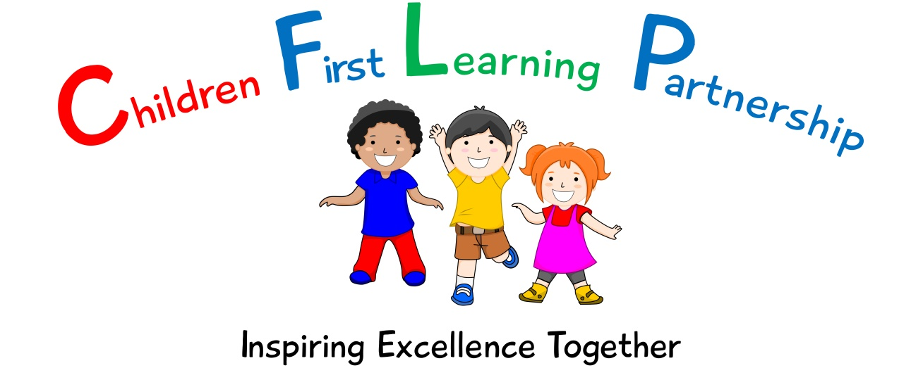

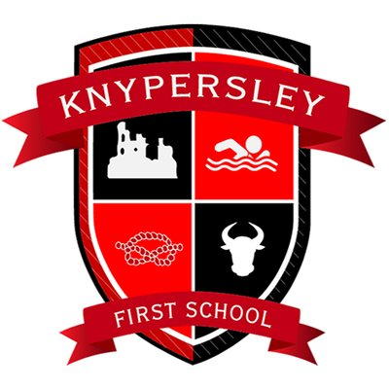

Phonics and Early Reading Policy 2022

July 2024 or earlier if required
To be reviewed:

Agreed and ratified by the Local Advisory Board on:
Head Teacher – Mrs Z Cooper

Responsible Officer:
Mr J Flowers
Chair of Board:
The CFLP Phonics Policy in respect of the Children First Learning Partnership has been discussed and adopted by the Local Advisory Board.

The overall intent of our school curriculum is to:

Recognise uniqueness: in our pupils, staff, resources and whole school community.
Be Inclusive: recognising learning styles, learning needs at all levels and providing solutions to any barriers to learning we encounter.
Engage and Inspire: through knowledge rich, highly enriched, progressive and purposeful contexts.
Promote Aspiration: offering challenge, accountability and responsibility for their learning.
Create citizens of the Future: who thrive on responsibility, see difference as a strength of our community and use democracy to embed their own values and beliefs.

Our phonics and early reading curriculum strives to drive all of these intentions and links very closely to the achievement and development of them all.

Intent
Phonics (reading and spelling)
At Knypersley First School, we believe that all our children can become fluent readers and writers. This is why we teach reading through Little Wandle Letters and Sounds Revised, which is a systematic and synthetic phonics programme. At Knypersley First school it is essential that our approach to teaching phonics and reading is accessible to all learners, regardless of background and that it promotes and fosters a life-long love of reading from the very beginning of their school journey.
We start teaching phonics in Nursery/Reception and follow the Little Wandle Letters and Sounds Revised progression, which ensures children build on their growing knowledge of the alphabetic code, mastering phonics to read and spell as they move through school.

As a result, all our children are able to tackle any unfamiliar words as they read. At Knypersley First School we also model the application of the alphabetic code through phonics in shared reading and writing, both inside and outside of the phonics lesson and across the curriculum. We have a strong focus on language development for our children because we know that speaking and listening are crucial skills for reading and writing in all subjects.

Comprehension
At Knypersley First School, we value reading as a crucial life skill. By the time children leave us, they should be able to read confidently for meaning and regularly enjoy reading for pleasure. Our readers are equipped with the tools to tackle unfamiliar vocabulary. We encourage our children to see themselves as readers for both pleasure and purpose.

Because we believe teaching every child to read is so important, we have a Reading Leader who drives the early reading programme in our school. This person is highly skilled at teaching phonics and reading, and they monitor and support our reading team, so everyone teaches with fidelity to the Little Wandle Letters and Sounds Revised programme.

Implementation
Foundations for phonics in Nursery
We provide a balance of child-led and adult-led experiences for all children that meet the curriculum expectations for ‘Communication and language’ and ‘Literacy’. These include:
- sharing high-quality stories and poems
  - learning a range of nursery rhymes and action rhymes
  - activities that develop focused listening and attention, including oral blending
  - attention to high-quality language.

We ensure Nursery children are well prepared to begin learning grapheme-phoneme correspondences (GPCs) and blending in Reception.
In nursery we expose the children to GPCs through a sound a week approach and modelling when necessary. This is to support the Literacy 3-4 years objectives in the EYFS development matters document.

Daily phonics lessons in Reception and Year 1
- We teach phonics for 30 minutes a day as a whole class. In Reception, we build from 10-minute lessons, with additional daily oral blending games, to the full-length lesson as quickly as possible. Each Friday, we review the week’s teaching to help children become fluent readers.
- Children make a strong start in Reception: teaching begins in Week 2 of the Autumn term.
- We follow the Little Wandle Letters and Sounds Revised expectations of progress:
  - Children in Reception are taught to read and spell words using Phase 2 and 3 GPCs, and words with adjacent consonants (Phase 4) with fluency and accuracy.
  - Children in Year 1 review Phase 3 and 4 and are taught to read and spell words using Phase 5 GPCs with fluency and accuracy.

Daily Keep-up lessons ensure every child learns to read
- Any child who needs additional practice has daily Keep-up support, taught by a fully trained adult. Keep-up lessons match the structure of class teaching, and use the same procedures, resources and mantras, but in smaller steps with more repetition, so that every child secures their learning. We will also take this opportunity to pre teach these children.
- We timetable daily phonics lessons for any child in Year 2 or above who is not fully fluent at reading or has not passed the Phonics screening check. These children urgently need to catch up, so the gap between themselves and their peers does not widen. We use the Little Wandle Letters and Sounds Revised assessments to identify the gaps in their phonic knowledge and teach these at pace.
- If any child in Year 1 or above has gaps in their phonic knowledge when reading or writing, we plan phonics ‘catch-up’ lessons to address specific reading/writing gaps. These short, sharp lessons last 10 minutes and take place at least three times a week.

Teaching reading: Reading practice sessions three times a week
- We teach children to read through reading practice sessions three times a week. These:
  - are taught by a fully trained adult to small groups of approximately six children
  - use books matched to the children’s secure phonic knowledge using the Little
Wandle Letters and Sounds Revised assessments and book matching grids on pages 11–20 of ‘Application of phonics to reading’
  - are monitored by the class teacher, who rotates and works with each group on a
regular basis.
- Each reading practice session has a clear focus, so that the demands of the session do not overload the children’s working memory. The reading practice sessions have been designed to focus on three key reading skills:
  - decoding
  - prosody: teaching children to read with understanding and expression
  - comprehension: teaching children to understand the text.
- In Reception these sessions start in Week 4. Children who are not yet decoding have daily additional blending practice in small groups, so that they quickly learn to blend and can begin to read books.
- In Year 2 and 3, we continue to teach reading in this way for any children who still need to practise reading with decodable books in order to increase automaticity, fluency and confidence levels.

Home reading
- The decodable reading practice book is taken home via an EBook link to ensure success is shared with the family.
- Reading for pleasure books also go home for parents to share and read to children.
- Every child accessing Little Wandle will receive weekly information sharing the learning that has taken place during the reading/ phonics sessions. The sounds, words and the main teaching focus will be explained in these weekly posts.
- We use the Little Wandle Letters and Sounds Revised parents’ resources to engage our families and share information about phonics, the benefits of sharing books, how children learn to blend and other aspects of our provision, both online and through workshops.

Additional reading support for vulnerable children
- Children in Reception and Year 1 who are receiving additional phonics Keep-up sessions read their reading practice book to an adult daily.
Ensuring consistency and pace of progress

- Every teacher in our school has been trained to teach reading, so we have the same expectations of progress. We all use the same language, routines and resources to teach children to read so that we lower children’s cognitive load.
- Weekly content grids map each element of new learning to each day, week and term for the duration of the programme.
- Lesson templates, Prompt cards and How to videos ensure teachers all have a consistent approach and structure for each lesson.
- The Reading Leader and SLT use the Audit and Prompt cards to regularly monitor and observe teaching; they use the summative data to identify children who need additional support and gaps in learning.

Impact
Assessment
Assessment is used to monitor progress and to identify any child needing additional support as soon
as they need it.
Assessment for learning is used:
- daily within class to identify children needing Keep-up support
- weekly in the Review lesson to assess gaps, address these immediately and secure fluency of GPCs, words and spellings.
Summative assessment is used:
- every six weeks to assess progress, to identify gaps in learning that need to be addressed, to identify any children needing additional support and to plan the Keep-up support that they need.
- by SLT and scrutinised through the Little Wandle Letters and Sounds Revised assessment tracker, to narrow attainment gaps between different groups of children and so that any additional support for teachers can be put into place.
- During the sixth week, teachers will also hear the decodable book that goes home each week (additional to the Little Wandle EBook) and will ensure these are closely matched to the new assessments taken. This is also an opportunity for the teacher to celebrate the home reading that has taken place.
The Little Wandle Letters and Sounds Revised placement assessment is used:
- with any child new to the school to quickly identify any gaps in their phonic knowledge and plan provide appropriate extra teaching.

Statutory assessment
Children in Year 1 sit the Phonics screening check. Any child not passing the check re-sits it in Year 2.

Ongoing assessment for catch-up
Children in Year 2 to 6 are assessed through:
- their teacher’s ongoing formative assessment
- the Little Wandle Letters and Sounds placement assessment
- the appropriate half-termly assessments.

Record Keeping
- Teacher record in the home school links book every six weeks
- Teacher records of the group reading sessions
- Phonics test for Y1 and above, where necessary

For further information on early reading, please see the English policy.

