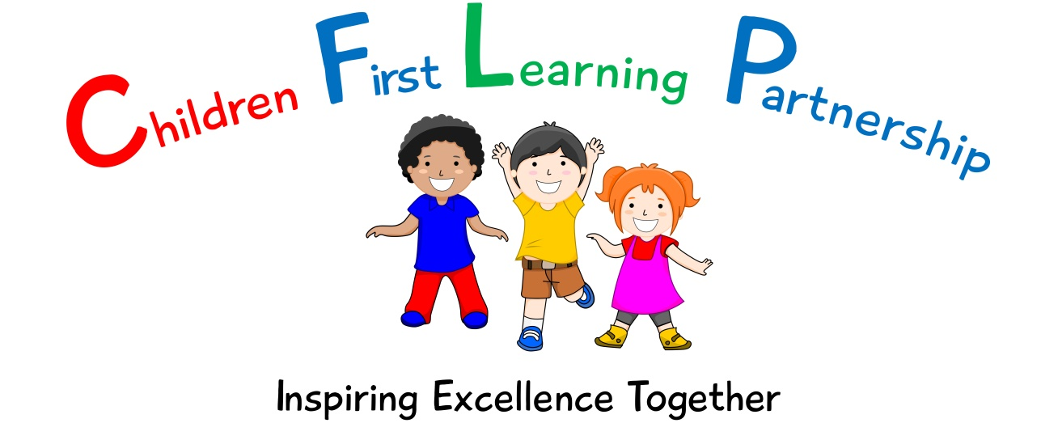

English Policy for
Knypersley First School
2022
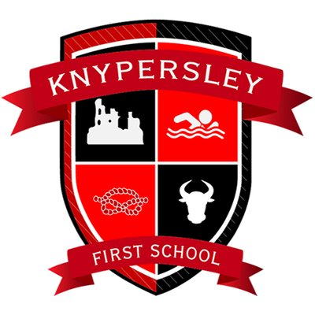

September 2022-Little Wandle Phonics Updates
To be reviewed:

Agreed and ratified by the Local Advisory Board on:
Executive Headteacher – Mrs A Rourke

Responsible Officer:
Mrs.J Holdcroft
Chair of Local Advisory Board:
The CFLP English Policy in respect of the Children First Learning Partnership has been discussed and adopted by the Local Advisory Board.

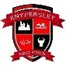
Knypersley First School Primary School
English Policy 2022
(To be read in conjunction with the school handwriting and spelling policies)

The overall intent of our school curriculum is to:
Recognise uniqueness: in our pupils, staff, resources and whole school community.
Be Inclusive: recognising learning styles, learning needs at all levels and providing solutions to any barriers to learning we encounter.
Engage and Inspire: through knowledge rich, highly enriched, progressive and purposeful contexts.
Promote Aspiration: offering challenge, accountability and responsibility for their learning.
Create citizens of the Future: who thrive on responsibility, see difference as a strength of our community and use democracy to embed their own values and beliefs.
Our English curriculum strives to drive all of these intentions and links very closely to the achievement and development of them all.
Intent
Our challenging and creative English curriculum aims to enable all pupils to achieve ambitious levels of literacy. Children are provided with an exciting and innovative curriculum which promotes a love of reading and a belief that everybody is an author.
Children are exposed to high quality literature to inspire their own writing and to model engaging uses of the English language. Through the critique of these texts, children develop their oral comprehension skills. Imagination and originality are nurtured through exploration, discussion and drama. Spelling, punctuation, grammar and phonics teaching ensure that children have the skills and confidence to develop their writing style across a range of genres and in varied contexts.
We recognise the importance of communication and language development in achieving academic success in English. Therefore, oracy is at the heart of our curriculum. Children are immersed in a language rich curriculum that intends to give all pupils an extensive vocabulary and oral proficiency.
Implementation
We use the National Curriculum programmes of study for Reading, Writing, Spelling, Grammar and Punctuation. We ensure that basic literacy skills are entwined through our text based units and the wider curriculum.
We deliver phonics through a systematic and synthetic approach, based largely on the Letters and Sounds document which is adapted to the needs of individual cohorts. (Please see appendix 2, phonics milestones document) We introduce exploration and teaching of Common Exception Words (CEW) alongside phonics so that our children gain the skills necessary for early reading.
Reading is an integral part of school life. We value reading and we have a reading core offer which is embedded within our everyday school practice. Our school uses a mix of phonically decodable, reading scheme and real books to support children’s development. This is delivered through individual, group and whole class teaching sessions using challenging texts to apply new skills and knowledge taught. (Please see Appendix 1 for our Reading band and Phonic Phase link document)
Reading for Pleasure
Our children deserve a rich curriculum that encourages a love of literature. All classes share books (in their entirety where possible) and are given access to a wide range of texts across different subjects. We believe that active encouragement of reading for pleasure is a core part of every child's educational entitlement, because we know that extensive reading and exposure to books makes a huge contribution to children’s vocabulary, understanding and subject knowledge. Reading is promoted through the use of our school libraries, class reading areas and whole school assemblies.
Spellings are explored, taught and practised regularly and are commented upon during marking conferences and live facilitation to ensure our high expectations are met. Children have a mixture of CEW and spelling patterns to learn on a weekly basis.
Writing
The progression documents show progression of writing skills across the school. At Children First Learning Partnership children are taught a range of genres to embed the basic skills across the curriculum.
Lessons are planned from the correct year groups Programmes of Study from The National Curriculum. Teachers will be aware of the prior learning that needs to be secure from previous year groups to ensure new content can be understood. The progression documents are then broken down into smaller steps to ensure lessons are driven by sharp learning objectives that are progressively linked. We use our flow of writing (See Appendix 3) to support the learning process and to practise and embed new skills and knowledge in the different genres.

Individual lessons are carefully designed using the most effective teaching materials, so that pupils are given the best opportunities to show their understanding. Variation is consciously built in by teachers, so that pupils can apply their learning to different genres and make cross curricular links.

We use pre cursive and cursive handwriting throughout the school. Staff teach the formation of letters specifically in the EYFS alongside phonics, saying a rhyme to aid memory and follow the school’s progression document for formation and joins. In line with the updates to the Early Years Curriculum, we now teach lead outs only in the Early Years and for our SEND children. (See Appendix 4)

English Language
Across the Children First Learning Partnership we understand that the English technical language is crucial to children’s thinking. So we introduce new words from the curriculum through text based units and WAGOLLs. Key vocabulary used in a text based unit/genre are displayed on the English working walls.
In lessons children work in a variety of ways including pairs; whole class, groups and individually. Children work together so that through their dialogue they can develop a much stronger understanding.

All adults model the correct use of technical language and insist pupils do the same, including correct use of standard English language.

Pitch, Pace and Challenge
Across the Children First Learning Partnership the expectation is that the majority of children will move through the units at broadly the same pace. However, decisions about when to progress will always be based on the security of children’s understanding and their readiness to progress to the next stage. Children will be taught analytical strategies which helps the children comprehend unfamiliar content.
Editing
Pupils are encouraged to develop a ‘have a go’ attitude and are comfortable with making mistakes, as they are seen as part of the learning process. Children have the opportunity to edit and improve their work.

Basic Skills
Embedding of basic skills within reading and writing and will enable pupils to accelerate their learning and close any gaps.
Impact-
What we aim to achieve from our English curriculum across the Children’s First Learning Partnership;
- Children will have a love of reading and a belief that everybody is an author.
- Children will have creative minds and build imagination and originality.
- Children will be secure in basic skills including SPAG and phonics.
- Children will have an extensive vocabulary and oral proficiency.
- Children will read and write for pleasure.
- Children will work collaboratively and independently to share ideas.
Assessment -
Our impact will be measured by using both formative and summative assessment.
Formative
Assessment is not just used to track children’s learning through the use of assessment trackers but also provides teachers with up-to-date and accurate information about the specifics of what children do and do not know. This information allows teachers to adapt their teaching so it builds on children’s existing knowledge and focuses on the next steps that they need in order to make progress.
Within the Children First Learning Partnership, assessment in English is continuous. From the beginning of every lesson, teachers and teaching assistants will be assessing prior knowledge through assessment for learning to identify the current stage and next steps in learning. Staff will facilitate to ensure that misconceptions are dealt with immediately and high attaining children are challenged appropriately. Our staff are highly skilled to provide a personalised and flexible curriculum for individual children that may need reasonable adjustments. These adaptations increase access to the lesson content, enabling them to reach their full potential.

Effective marking and feedback are an important element of teachers and TAs responses to children’s learning. This may be given either orally during live marking or in written format during a marking conference, but is always:
- specific, accurate, and clear
- celebrates success
- compares what a pupil is doing right now with what they have needed to improve before
- provides specific guidance on how to improve as their next step
Summative
As part of our assessment and to support teacher’s judgements, each class will undertake a half termly formal assessment of SPAG and phonics. This is then converted and analysed through scaled scores which are evaluated termly by English leaders and acted upon quickly to direct CPD, resources and support to help pupils to overcome barriers to learning or from reaching their full potential.
Role of Leaders
- Plan an effective and varied schedule of monitoring including moderation, which is triangulated through our in school, leader and triad moderation, so that the Quality of Education in English is embedded throughout the school and the CLFP.
- Respond quickly and in a supportive manner to overcome barriers to implementation and impact.
- Use assessment information to provide effective CPD and challenge.
- Provide clear updates to the Local Advisory Board, Headteacher and SLT.

Version | Review Date | Changes Made
V2 | 14.01.2022 | Reading – referenced Reading Core Offer
 |  | Writing (Handwriting) - changes to EYFS (&SEN) handwriting formation – letter formation lead out only.
 |  | Role of Leaders – moderation triangulation through in house, leader monitoring and triad
 |  | Appendix 2-Updated phonic milestones

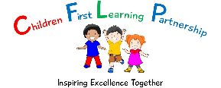
Appendix 1

Book Band | Teacher assessment | Revised Phonic Order -Year group | Phonics stage (L&S document)
Pearl (free) | 5D and beyond
Diamond | 5E
Sapphire | 4S
Emerald | 4D
Ruby | 4E
Topaz | 3S
Copper | 3D
Lime | 3E
White | 2S
Gold | 2D
Purple | 2E | Y2 | Phase 6
Turquoise | 1S/2E | Y1 & Y2 | Phase 5
Orange | 1S | Y1 | Phase 5
Green | 1D | Y1 | Phase 5
Blue | 1E | RC & Y1 | Phase 3 & alternatives from 5
Yellow | RS/1E | RC & Y1 | Phase 3 & alternatives from 5
Red | RD/RS | RC | Phase 2
Pink | RE/RD | RC | Phase 2

Phase 4 incorporated into revised phonic order in Reception

Appendix 2
Phonics Milestones
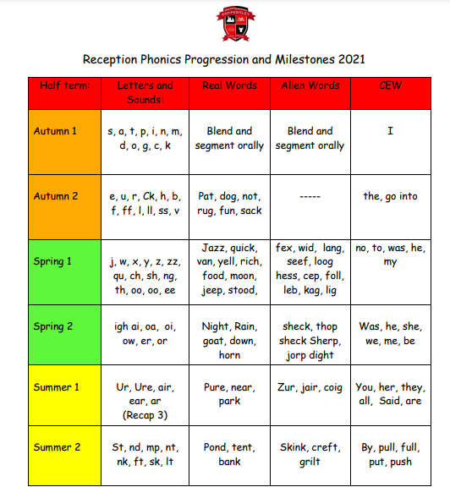
Year One Phonics Progression and Milestones 2021
Half term: | Letters and Sounds | Real Words | Alien Words |  | CEW Read | CEW Spell | Book scheme and colour
Autumn 1 | Revise Phase 3 and teach phase 4  st, nd, mp, nt, nk, ft, sk, lt, lp, lf, lk, pt, xt, tr, dr, gr, cr, br, fr, bl, fl, gl, cl, pl, sl, sp, tw, sm, pr, sc, sn, nch, scr, shr, thr, str  28+/35 -OT | pond  tent  bank  blast  scrunch  next  clown  scoop  branch  sniffs  frog  thrill  jump  10+ - OT | skink  creft  grilt  frilk  smalf  drem  glop  plair  strear  twing  slar  shroit  drelp  prell  11+ OT |  | I, he, she, we, me, be,  to, do no, so, go,  the, they  was, you, is, his, has, my, by, her, of, push, pull, full, put  21+ OT | I, he, she, we, me, be,  to, do no, so, go,  the, they  was, you, is, his, has, my, by, her, of, push, pull, full, put  21+ OT | Letters and sounds (green)  Big Cat Collins (red and yellow)  RS/1E
Autumn 2 | Teach phase 5  ay, ou, ie, ea, oy, ir, ue, aw, wh, ph, ew, oe, ew, ue, au,  12+ OT | whip  fried  few  today  bead  boy  haunt  5+ OT | plouts  spraw  zeab  plue  cloy  choe  girt  5+ OT |  | are, said, were, here, there, one, our, where, ask,  today, come, some, love, your, says,  12+ OT | are, said, were, here, there, one, our, where, ask,  7+ OT | Letters and sounds phase 5 (purple)  Big cat Collins (yellow and blue) 1E
Spring 1 | Teach phase 5  a-e, e-e, i-e, o-e, u-e, i(find), o (cold),  c (cell), g (giant),  u (unit),  8+ OT | label  cell  kind  toe  unit  giant  nose  5+ OT | phope  meve  bave  stribe  zude  4+ OT |  | once, house, friend, school, come  3+ OT | today, your, says, some, come, love, once, house, friend, school,  8+ OT | Letters and sounds phase 5 (purple)  Big Cat Collins  (blue and green)  1E/1D
Spring 2 | Teach phase 5  e (delay), ow, ie, ea, a (acorn), a (want), a (father), y (very), y (by), ch (chef), ch (school), ou, ore  10+ OT | acorn  delay  my  head  chef  mould  fold  school  shield  head  stroke  father  want  would  11+ OT | chey  bly  doup  2+ OT |  | Recap all CEW and introduce the days of the week  36+ OT | Days of the week | Letters and sounds phase 5 (purple)  Big Cat Collins  (green and orange)  1D/1S
Summer 1 | Review all phases | Recap all real words from phase 4 and 5  26+/33 OT | Recap all non-sense words from phase 4 and 5  26+/33 OT |  | Oh, their, people, Mr, Mrs, looked, called, asked, could, today, have, give, don't, old, I'm, time, about, made, came, make, here, saw, very, point, says  20+/25 OT | Check spelling of all year one CEW  36+/45 OT | Letters and sounds fluent readers (red)  Big Cat Collins  (orange)  1S
Half term: | Reading |  |  | Spelling |  |  | Book scheme and colour
Summer 2 | W8. To read words with contractions [for example, I’m, I’ll, we’ll], and understand that the apostrophe represents the omitted letter(s)  W5. To read words containing taught GPCs and –s, –es,-ies, –ing, –ed, –er and –est endings |  |  | S12. To spell compound words  S16. To use the spelling rule for adding –s or –es as the plural marker for nouns and the third person singular marker for verbs  S17. To add the prefix ‘un-‘ to the beginning of words (verbs e.g. kind, unkind)  S18. To use –ing, –ed, –er and –est where no change is needed in the spelling of root words [for example, helping, helped, helper, eating, quicker, quickest] |  |  | Letters and sounds fluent readers (red)  Big Cat Collins  (orange and turquoise)  1S OR ABOVE

Appendix 3
Flow of writing

Prior Learning | Explore | Develop | Dazzle Me
- List the features  - Sorting activity – sentences, extracts  - Spider diagram  - Comparison of two texts – Non fiction,fiction  - Cold write  - Odd one out – Which one is the letter?  - Tense of language  - Bad WAGOLL – Spot the mistakes | - Identify features, highlighting  - WAGOLLs  - Drama – hot seating, conscience alley, retell role play, small world re-enactment  - Story mapping  - Sequencing  - Freeze framing  - Piecing together | - Planning  - Skills and sentences  - Writing elements of the genre  - Exploring skills  - Writing a full piece of genre – retells, twists, own versions  - Up-level/improve group/teachers version  - Guided writing | - Edit,  - Redraft  - Up-level language – thesaurus, wordbank, resources  - Up-level spellings – dictionaries, zap its  - Peer assessment  - Self assessement against criteria

Appendix 4
Handwriting Progression

